BPL Suggested minibus routing:
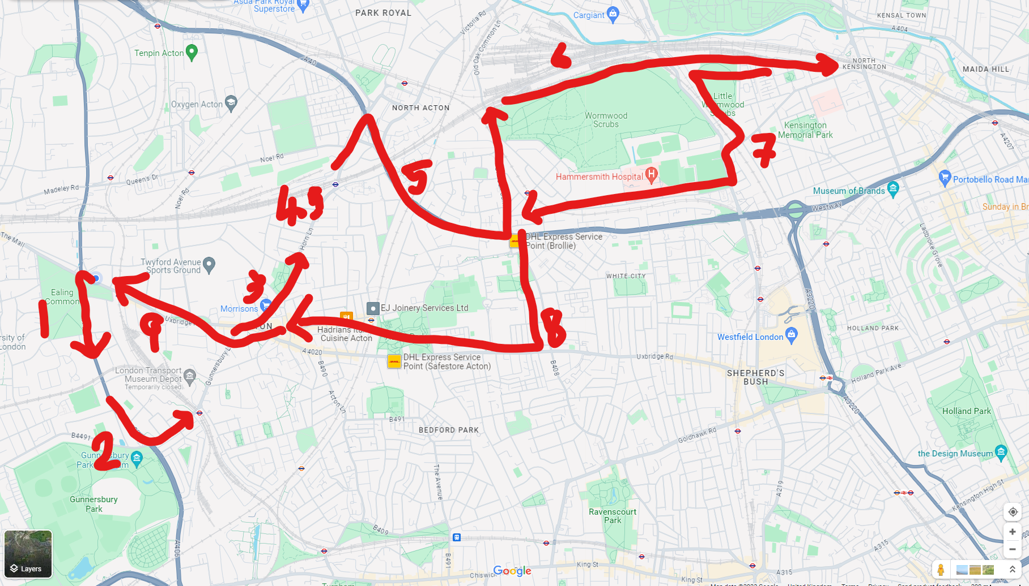

- Gunnersbury Avenue
- Gunnersbury Lane
- Horn Lane
- Jewson’s and Friary Road
- Horn Lane to A40 and Old Oak Common Lane
- North Pole Depot
- Mitre Way, Scrubbs Lane and Du Cane Road
- Old Oak Road
- Acton Vale

